RE-STORE MARKETING
OVERVIEW REPORT

March 25, 2019

OVERVIEW
Congratulations! You now have a solid foundation from which to grow your online presence. Your website is now prepared to host new and returning visitors and provide them with relevant, helpful information about your offerings.

This report will provide you with an overview of all the recent marketing efforts that have been completed for Re-Store. You’ll also find next steps to ensure these efforts are maintained and utilized in the future.

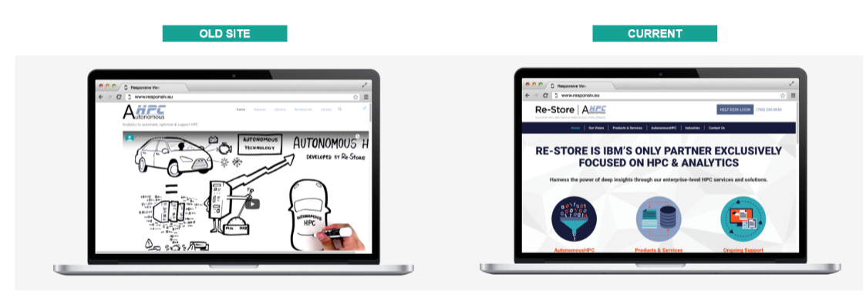

SEARCH ENGINE OPTIMIZATION (SEO)
SEO fixes help improve your site’s visibility in organic search engines like Google. When people can find your website in search, your site receives free, relevant, and qualified traffic which can turn into leads for your business.

Original Audit Score: 69%
Updated Audit Score: 90% (30.4% improvement!)
Wins:
- Organic traffic: 70.43% Increase ↑
- New website users: 68% Increase ↑
- Pageviews: 61.27% Increase ↑
- Pages redirected
- Sitemap fixed
- Duplicate content removed or changed

WEBSITE IMPROVEMENTS & CONVERSION RATE OPTIMIZATION (CRO)
Re-Store’s website has been redesigned to improve the site’s performance for visitors.
Wins:
- New design is modern and professional, and guides visitors to relevant pages
- Links added to navigate between pages
- Heatmaps and recordings installed & monitoring visitor’s experiences
- Images and content have been reformatted for a better visitor experience
NEXT STEPS
Recommended next steps for Re-Store marketing efforts:
- Repurpose existing video content into social media banners with quotes/testimonials
Example: 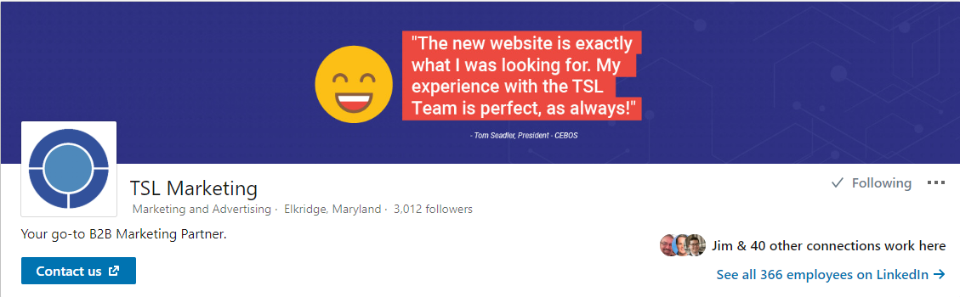
- Grow Re-Store’s visibility on social media with content repository / repurposed content
- Consolidate and optimize Re-Store YouTube channel and videos
- CRO - Finalize a bottom of funnel (BOFU) offer for potential customers that are ready to learn more about Re-Store
- SEO - Continue to optimize for mobile devices
- SEO - Reduce server response time to make site faster
- SEO – Expand existing content, improve page descriptions
- SEO - Backlink auditing & build backlink strategy to build online credibility

