CARRIER LOGISTICS MARKETING
OVERVIEW REPORT

March 26, 2019

OVERVIEW
Congratulations! You now have a solid foundation from which to grow your online presence. Your website is now prepared to host new and returning visitors and provide them with relevant, helpful information about your offerings.

“Websites exist because when people have problems,
they want to see if you can help them.”

This report will provide you with an overview of all the recent marketing efforts that have been completed for Carrier Logistics. You’ll also find next steps to ensure these efforts are maintained and utilized in the future.

Before  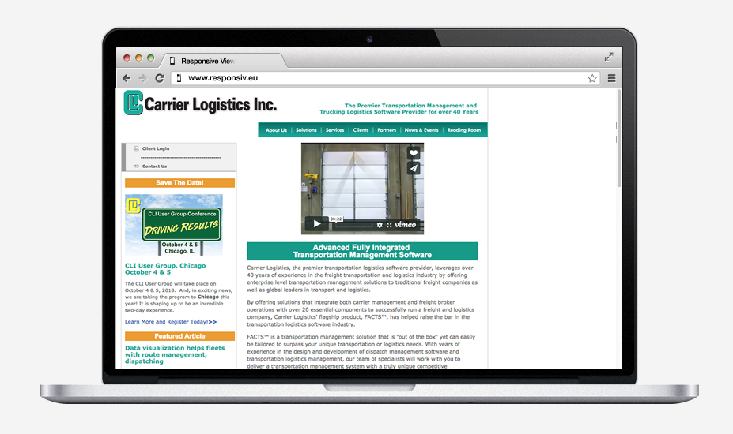 | After  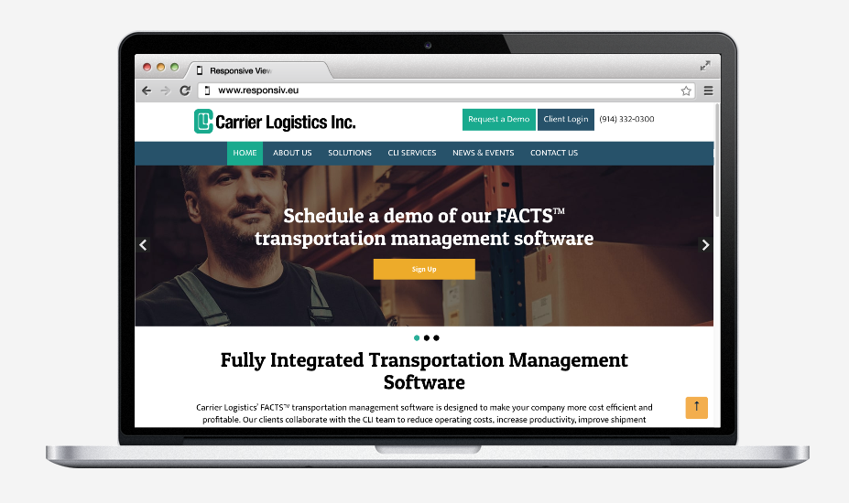

SEARCH ENGINE OPTIMIZATION (SEO)
SEO fixes help improve your site’s visibility in organic search engines like Google. When people can find your website in search, your site receives free, relevant, and qualified traffic which can turn into leads for your business.

Original Audit Score: 63%
Updated Audit Score: 92% (46% improvement!)
Wins:
- Analytics tracking installed for more accurate data collection
- Pages redirected or removed to concentrate
- Duplicate content removed or changed
- Content consolidated to clarify keywords & audience
- Internal links to improve context for search engines

Organic Search Performance
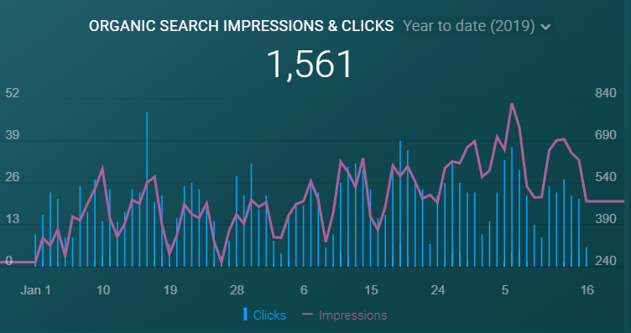

User type – New vs. Returning (Last 30 days)
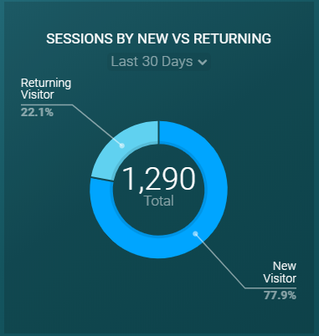

WEBSITE IMPROVEMENTS & CONVERSION RATE OPTIMIZATION (CRO)
Carrier Logistics website has been redesigned to improve the site’s performance for visitors.
Wins:
- New design is modern and professional, and guides visitors to relevant pages
- Lead-generating forms added for a demo
- Links added to navigate between pages
- Heatmaps and recordings installed & monitoring visitor’s experiences
- Images and content have been reformatted for a better visitor experience
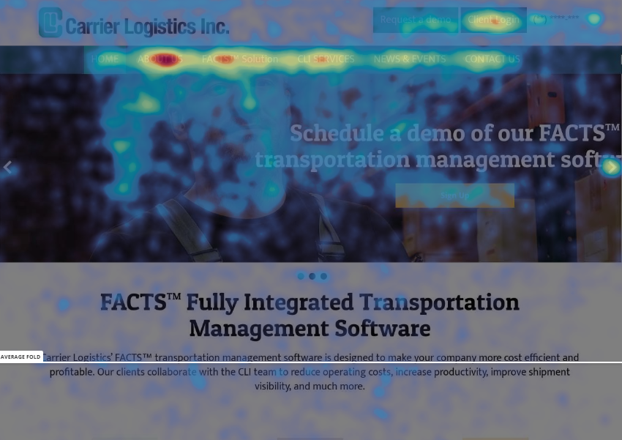
Website Performance
Top 5 Pages (Website Traffic & Time on Page)
- Home Page
- FactsTM Solution
- About Us
- Contact Us
- Meet the Executive Team

NEXT STEPS
Recommended next steps for Carrier Logistics marketing efforts:
- Organic Social Media Strategy - Develop social media content strategy & monthly repository to drive website traffic, share testimonials, demonstrate thought leadership, and build credibility.
- LinkedIn Ad Campaign – Promote the demo and/or new blog articles on LinkedIn to drive new-to-Carrier Logistics visitors and generate digital leads.

SEO Next Steps:
- Target non-branded keywords to attract new-to-Carrier Logistics visitors
- Long-form article blog strategy targeting important keywords
- Expand existing content, improve page titles & descriptions
- Develop a strategy for collecting client reviews on Google & Facebook to build authority

CRO Next Steps:
- Wrap up the set up of MailChimp & email series to collect and nurture digital leads
- Integrate call-to-action to eBook throughout the site & email series to nurture eBook leads
- Add contact information & social profiles to executive team members on “Meet the Executive Team” page
- Spread client testimonials throughout the website
- Change homepage carousel to static image with call-to-action

